# Neural Network

**Business Objective:** Build a Neural Network model for 50_startups data to predict profit

Step 1: Install all the package for Neural Network and read the file.

Step 2: Convert the categorical data to numbers.

Step 3:

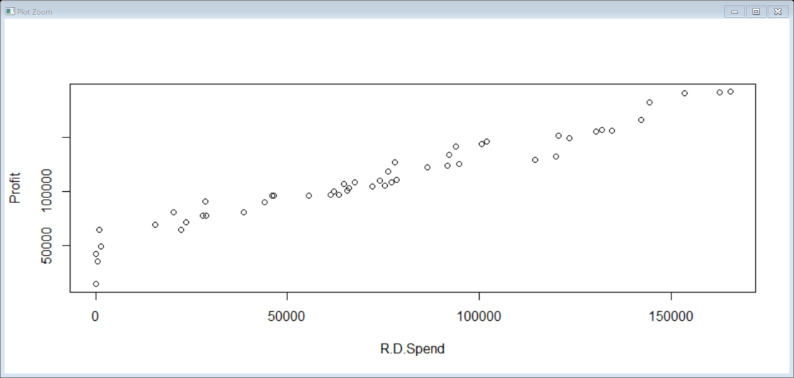

Step 4:

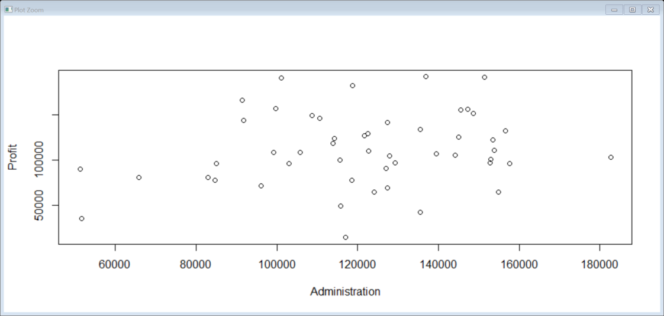

Step 5:

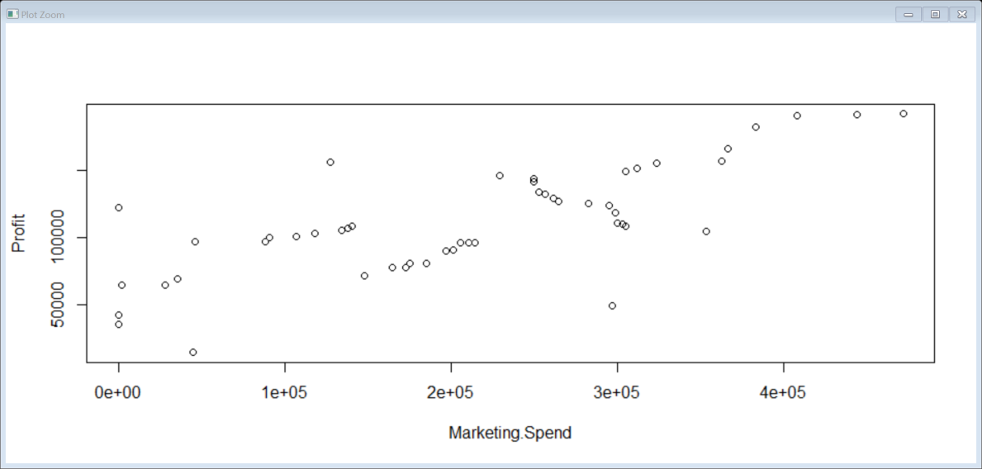

Step 6:

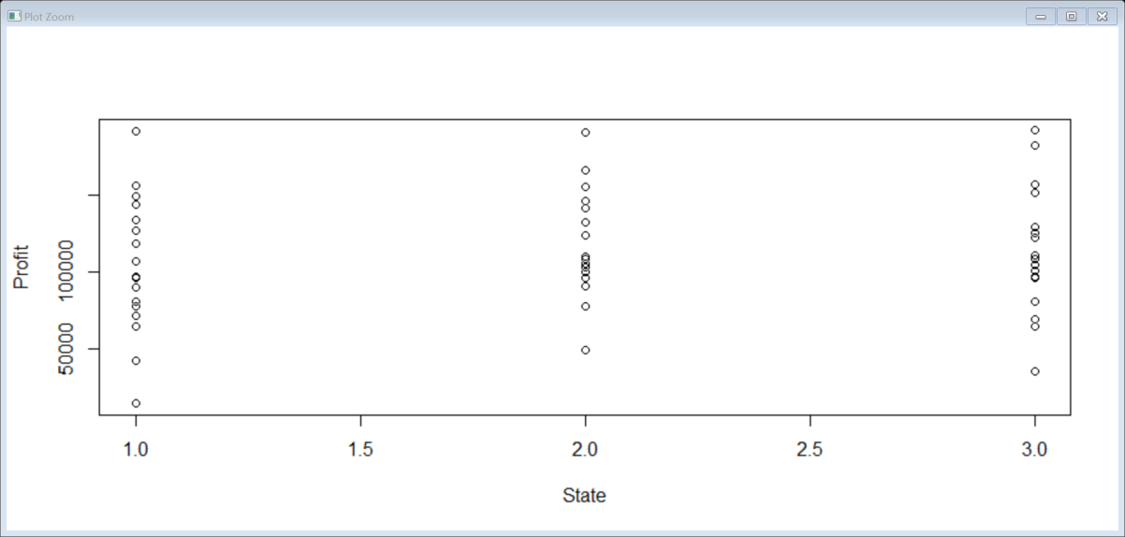

Step 7: There is a strong correlation between RD speed and Profit.

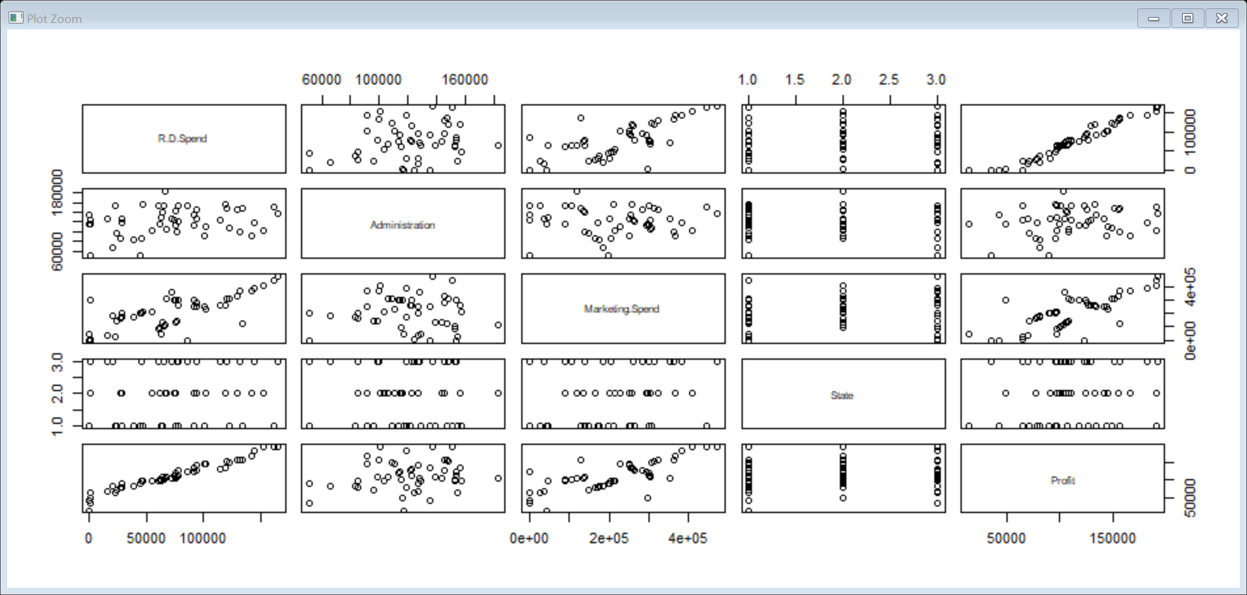

Step 8:

summary(Startups_norm$Profit)

Min. 1st Qu. Median Mean 3rd Qu. Max.

0.0000 0.4249 0.5254 0.5481 0.7044 1.0000

Step 9:

summary(Startups$profit)

Length Class Mode

0 NULL NULL

Step 10:

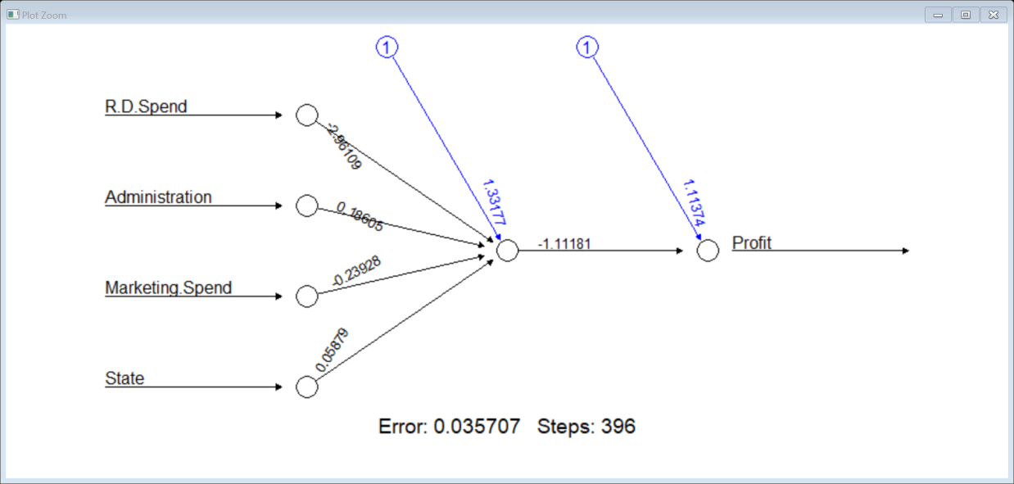

Step 11:

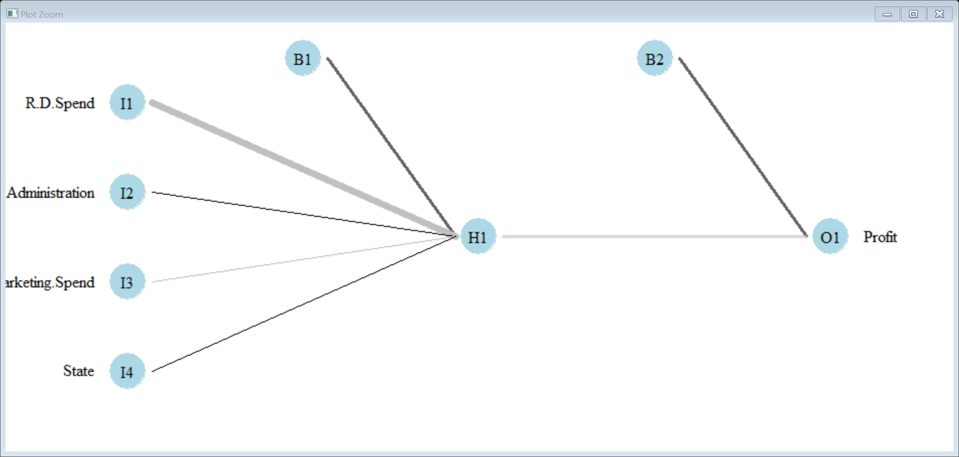

Step 12: Predicted profit Vs Actual profit of test data.

0.9556348

Step 13:

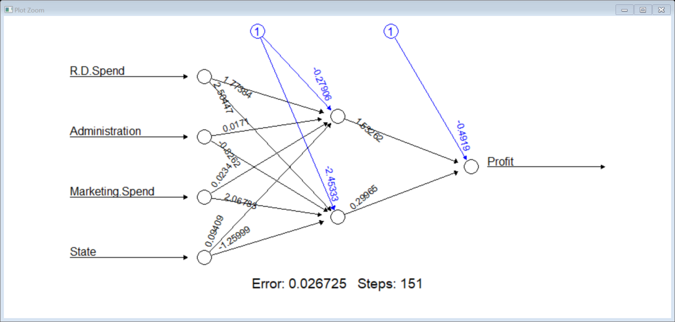

Step 14: 0.9639338 Predicted with test value

Step 15:

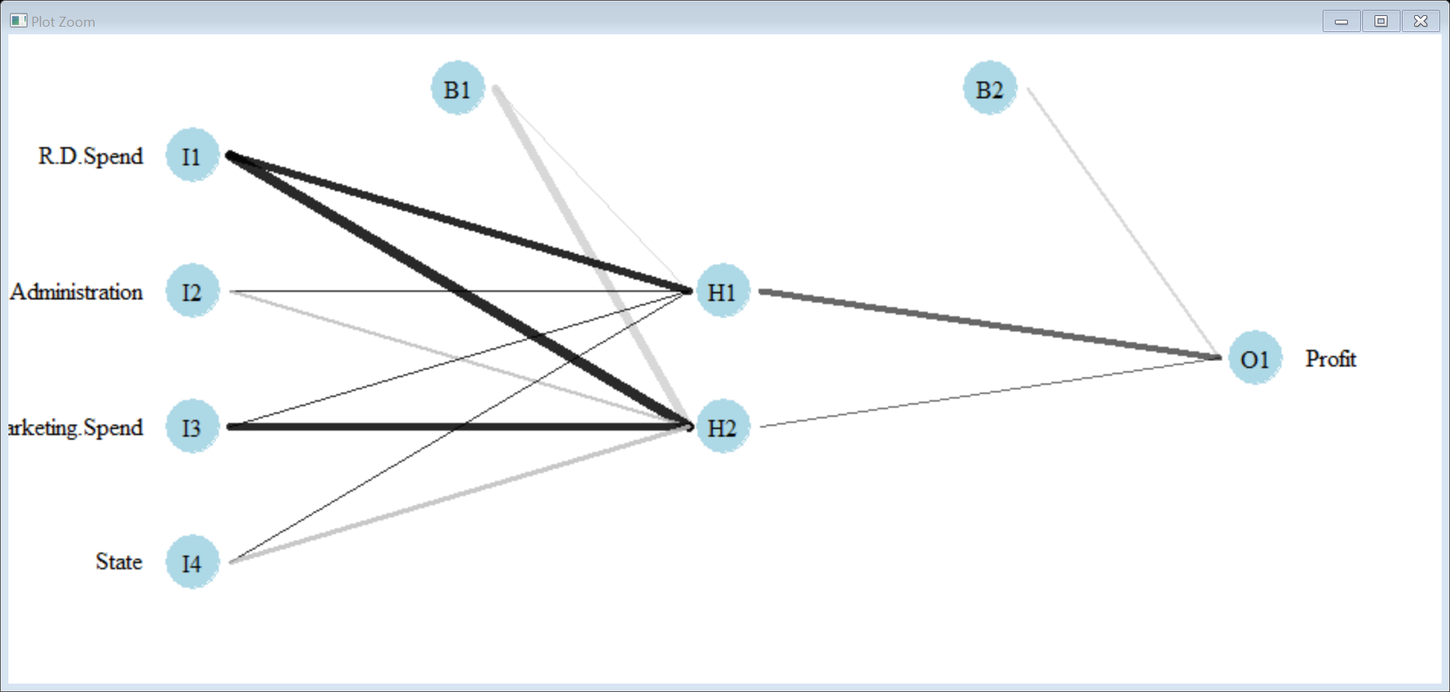

**Business Objective:** Prepare a model for strength of concrete data using

Neural Networks

Step 1: Install all the package for Neural Network and read the file.

Step 2:Histogram of Concrete with Cement and draw line of density.

summary(concrete$cement)

Min. 1st Qu. Median Mean 3rd Qu. Max.

102.0 192.4 272.9 281.2 350.0 540.0

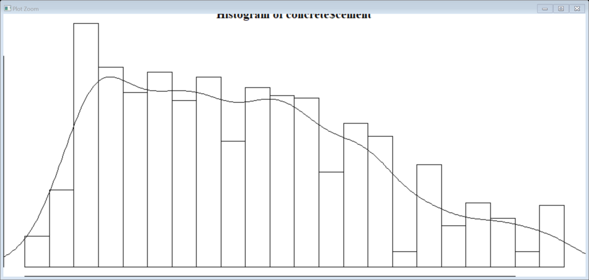

Step 3: Histogram of Concrete with slag and draw line of density

summary(concrete$slag)

Min. 1st Qu. Median Mean 3rd Qu. Max.

0.0 0.0 22.0 73.9 142.9 359.4

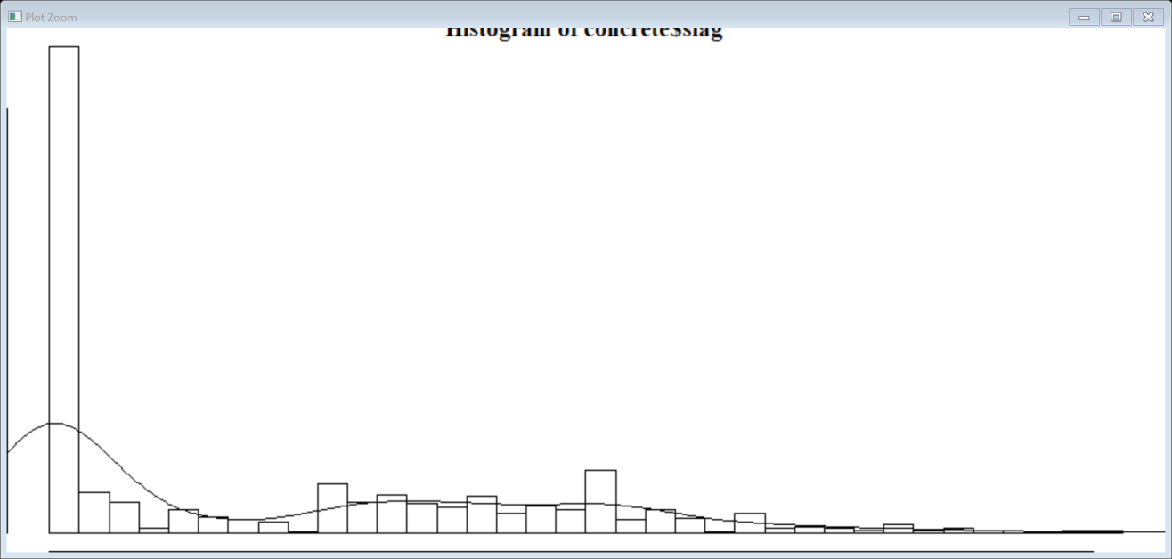

Step 4:Apply normalize function on strength

Min. 1st Qu. Median Mean 3rd Qu. Max.

0.0000 0.2664 0.4001 0.4172 0.5457 1.0000

Step 5: Predicted strength Vs Actual Strength of test data = 0.81

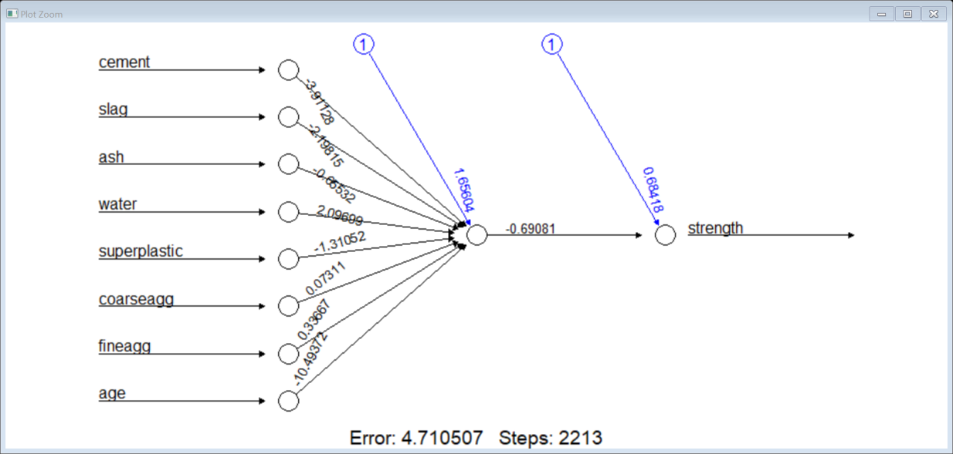

Step 6: Predicted strength Vs Actual Strength of test data.

0.8100659

Step 7: Improve the model performance by applying the neural network model on train data and plot

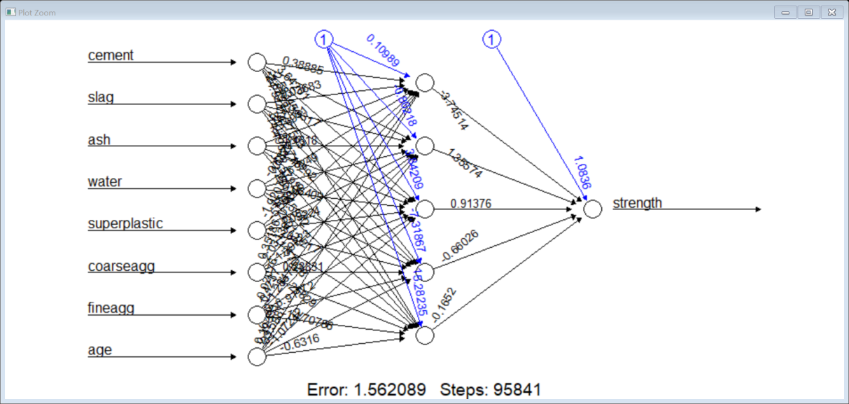

Error: 1.562 and Steps: 95841

**Business Objective :** PREDICT THE BURNED AREA OF FOREST FIRES WITH NEURAL NETWORKS

Step1: : Install all the package for Neural Network and read the file.

Step 2: Convert the categorical data to numbers.

Step3 : Below is the graphical representation of the datasets

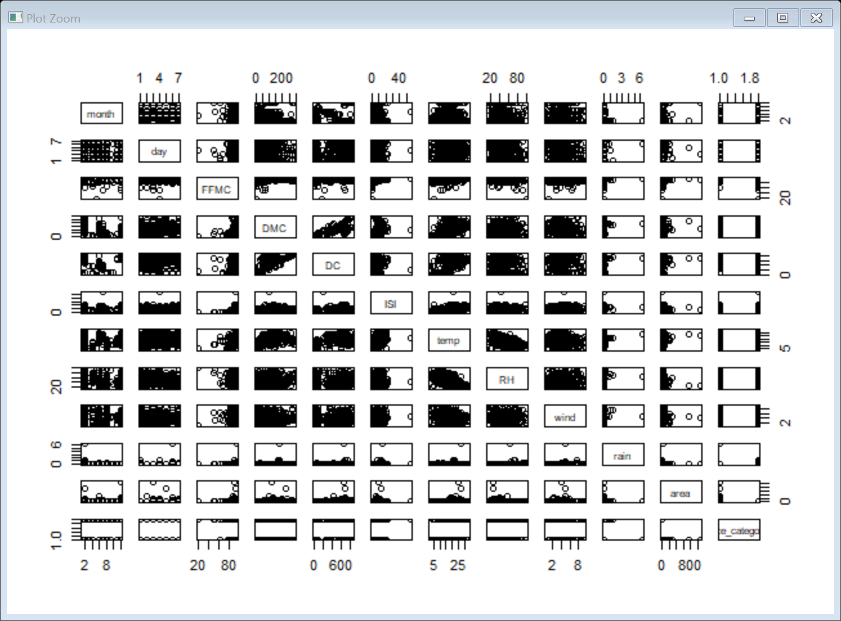

Step 4:

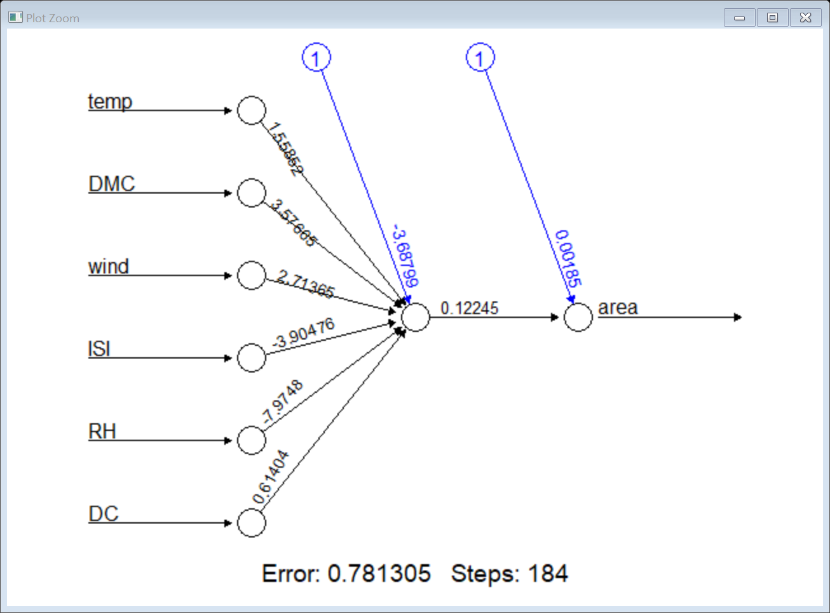

Step 5:

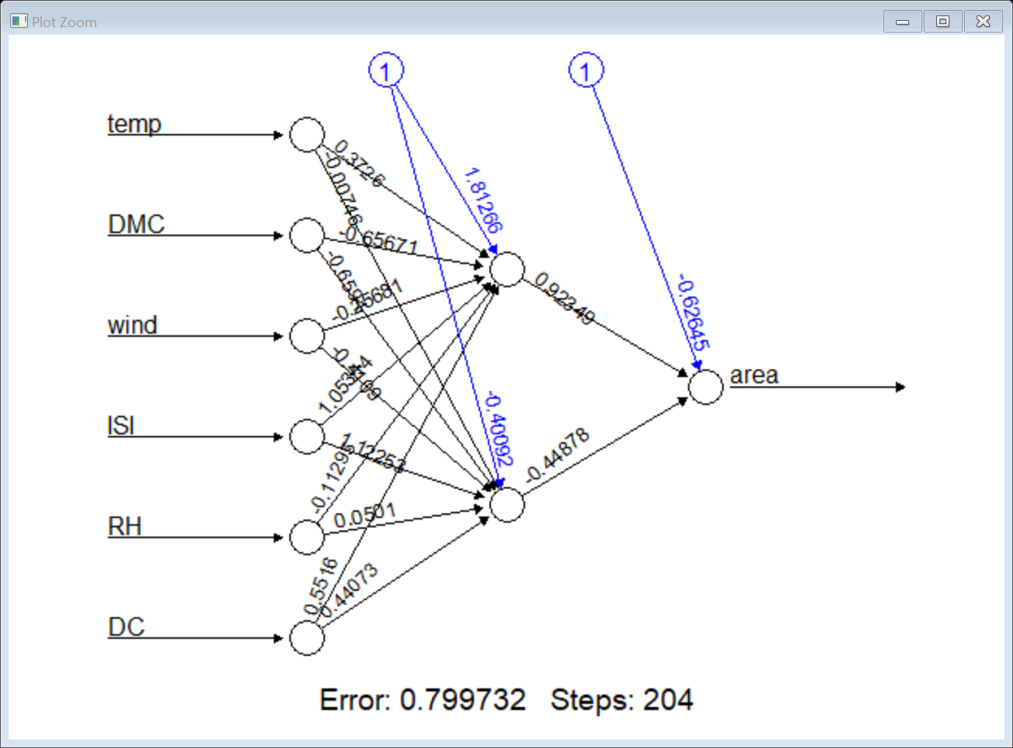

Step 6:

